August 2, 2023

The Honorable Asisaun Toovak
Mayor, City of Utqiagvik
P.O. Box 629
Utqiagvik, Alaska 99723

Madam Mayor Toovak,

Greetings from Iḷisaġvik College! The City of Utqiagvik has a designated seat on the Iḷisaġvik College Board of Trustees. That seat is currently held by Ms. Heather Dingman and will expire on December 31, 2023.

We are kindly requesting for the City of Utqiagvik to begin accepting Letters of Interest from the community of Utqiagvik to fill the vacancy. A Press Release has been attached for you to be posted in the community.

The Iḷisaġvik College Board of Trustees has an important role on the North Slope as they guide the College’s administration in fulfilling the mission to provide quality higher education and training to the residents of this region. Compensation includes honorarium, loss of pay, and travel expenses.

Once the letters of interest have been received at your office, we respectfully request that the City Council, at their next meeting, nominate one (1) name for the North Slope Borough Mayor’s consideration. Once the names have been identified by the Council, please send a letter to my office, and we will, in turn, forward the nominations to the North Slope Borough Mayor and Assembly for consideration.

Quyanaqpak for your attention to this matter. If you have any questions, please do not hesitate to contact me at 907-852-1820.

Sincerely,
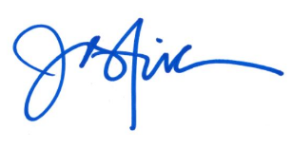
Justina Wilhelm, MSW
President

Attachment: Press Release

