PUBLIC NOTICE

TAXICAB COMMISSION MEETING
Saturday, May 27, 2023 at 3:00 pm
Nathaniel Olemaun, Jr., Mayor Emeritus, City Hall Administration Building
CITY COUNCIL CHAMBERS

To the General Public:
You are hereby notified that the Taxicab Commission Meeting is scheduled for May 27, 2023 at 3:00 pm in the City Council Chambers, Nathaniel Olemaun, Jr., Mayor Emeritus, City Hall, Administration Building, Utqiaġvik, Alaska.

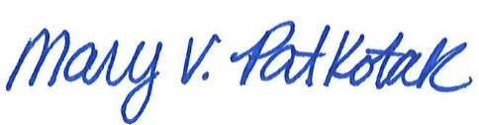
5/17/2023
Mary V. Patkotak, City Clerk Date

